РАБОЧАЯ ТЕТРАДЬ №3

ЗАДАНИЕ 1
Возьмите Карту №3 и пройдите по указанному маршруту. Найдите музейный предмет. Прочтите этикетку и запишите его название по-английски.

ЗАДАНИЕ 2
Прочите нижеприведенные слова.
- carved bone – резная кость
- сasket– ларец
- to be covered – быть покрытым
- deer – олень
- eagle – орел
- hare – заяц
- lion - лев
- made of – сделан из
- top – верх/крышка
- sides – стороны
- piece of eighteenth century furniture – предмет мебели XVIII века
- wood – дерево/древесина

Вставьте слова в текст.

It is a ___________ . It is ________of ________and is __________ with _________. There are ornaments with animals, leaves and flowers on the_______ and on the _____ . There is a ________ , a ________, a__________, an __________ in this magic forest.

Прослушайте краткий рассказ учителя о предмете и подготовьтесь к презентации музейного предмета. Каждый из вас выступит в роли экскурсовода.

ЗАДАНИЕ 3
Прочтите сказку и переведите ее на русский язык, используя слова из ниже приведенного словарика.

  - Once upon a time there lived a Girl. Her family was very poor and she always wanted to help her mother and father. So, she went to the wood to gather some brushwood. They could sell it and earn some money. Suddenly she saw a Hare. The Hare was crying.
  - “I lost my little son!”.
  - “Here it is!” said the Girl. “It is sleeping under the bush!”
  - “Thank you!” said the Hare.
  - The girl went on – and soon she met a Deer with long horns. It couldn’t move.
“What happened?” asked the Girl.

“My long horns were entangled in the tree branches of this tree!”

The Girl climbed the tree and helped the Deer.

“Thank you”, said the Deer.

And then she met a Lion who had a splinter in its paw.

“I am in pain!” said the Lion.

The Girl pulled the splinter out. She helped them all but she still didn’t gather her brushwood! The Girl began to cry. She was frightened and lonely! Suddenly the Lion, the Deer and the Hare came back!
“Here is a casket of gold and you will never be poor!” said the Lion.
The Deer brought her a bunch of brushwood.
“Here is a bunch of brushwood you will always be warm and you can always sell it to other people”, and took her on its back to her village.
And the Hare gave her a little sack full of food.
“This is a magic sack”, said the Hare. “You will never be hungry again!”

СЛОВАРИК

Wood - лес  Gather – собирать  Sell - продавать  Brushwood - хворост  Bunch of - связка | Earn money – зарабатывать деньги  bush - куст  horn – рог  entangled – запутавшийся | branches – ветви  splinter – заноза  paw – лапа

Найдите соответствие английского слова и картинки.

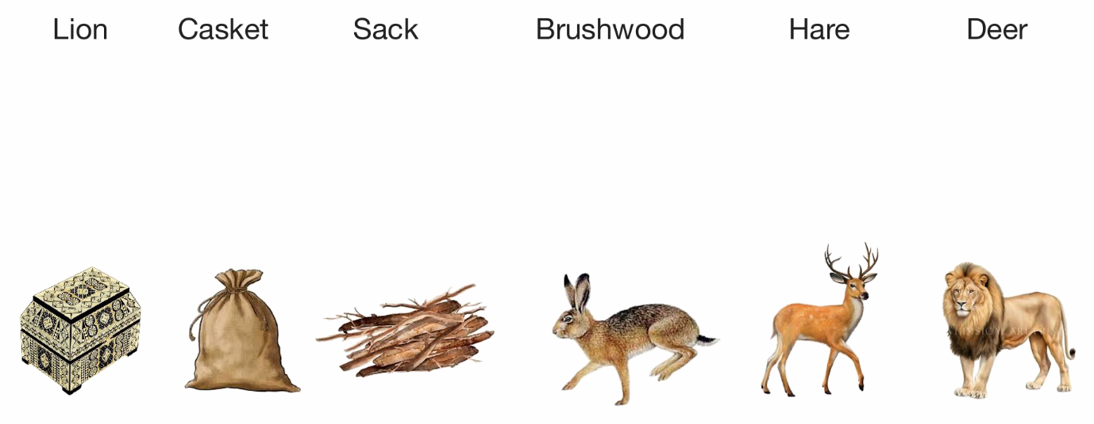

ЗАДАНИЕ 4
Выберите себе роль и прочтите сказку для других участников. Назовите свою роль, используя конструкцию I will be the …
Роли:
Author
Girl
Hare
Deer
Lion

ЗАДАНИЕ 5
USE - ИСПОЛЬЗОВАТЬ
ENJOY - НАСЛАЖДАТЬСЯ
ORNAMENT - ОРНАМЕНТ
GEOMETRIC - ГЕОМЕТРИЧЕСКИЙ
FLORAL – ЦВЕТОЧНЫЙ
COLORS – ЦВЕТА
IMAGES - ОБРАЗЫ
IRON - ЖЕЛЕЗО
GLASS - СТЕКЛО
WOOD – ДЕРЕВО
TEXTILE - ТКАНЬ
BONE – КОСТ Ь
STONE – КАМЕНЬ
CARVING - РЕЗЬБА
EMBROIDERY – ВЫШИВКА
PAINTING – ЖИВОПИСЬ
OBJECTS OF DECORATIVE ART – ПРЕДМЕТЫ ДЕКОРАТИВНОГО ИСКУССТВА
THE ALL-RUSSIAN DECORATIVE ART MUSEUM – ВСЕРОССИЙСКИЙ МУЗЕЙ ДЕКОРАТИВНОГО ИСКУССТВА

